Analysis and Prediction of Post-Transplant Outcomes in Heart Failure Patients Using XGBoost Models
Dr.N. Leelavathy¹, Sanku Srija Veera Surya Thomala², Erina Mondal³, P.V.V. Satyanarayana⁴
Godavari Global University¹, ^{2, 3, 4}Godavari Institute of Engineering and Technology
daa@ggu.edu.in, srijasanku@gmail.com, erinamondal2001@gmail.com, pveeravenkatasatyanarayana4@gmail.com

Abstract— Heart transplant outcome prediction remains challenging due to complex donor-recipient interactions and multiple clinical variables. Current approaches focus on single outcomes with limited personalization. We propose a comprehensive multi-task machine learning framework using XGBoost models to simultaneously predict survival probabilities (1, 5, 10 years), rejection risk, quality-of-life scores, and rehospitalization rates. Our system integrates 25+ clinical, demographic, lifestyle, and socioeconomic features from 1,000+ patient-donor pairs in the UNOS database. The XGBoost Classifier achieves AUC values of 0.91, 0.88, and 0.86 for 1-, 5-, and 10-year survival prediction, respectively, while the rejection risk model achieves 0.85 AUC. Regression models for quality-of-life (R² = 0.76) and rehospitalization (R² = 0.72) demonstrate strong predictive capability. Statistical validation shows significant improvement over traditional Cox regression models (p < 0.001). The framework is deployed as a secure web application with SHAP-based interpretability features. This multi-output approach provides clinicians with comprehensive, interpretable predictions supporting personalized post-transplant care decisions.
Keywords—Heart Transplant, Machine Learning, Predictive Analytics, XGBoost, Survival Prediction, Clinical Decision Support System, Flask, FAISS, Healthcare AI.
I. INTRODUCTION
Heart transplantation is a life-saving treatment for patients with end-stage heart failure. It offers longer survival and better quality of life. However, predicting what happens after the transplant — such as survival, organ rejection, or hospital readmissions — remains very difficult. These outcomes depend on many complex factors, like patient health, donor characteristics, and clinical conditions. Accurate predictions are important to improve donor–recipient matching and post-surgery care.
Each year, more than 3,000 heart transplants take place in the U.S., with about 87% of patients surviving the first year and 75% living beyond five years [ISHLT]. But current tools for risk prediction are not very accurate, especially for long-term outcomes (AUC < 0.75) [1,2]. This makes it hard for doctors to make confident decisions about treatment planning and patient counseling.
Traditional methods like Cox models and registry-based scores have been used for predictions. However, they assume linear relationships and don’t fully capture the complex nature of transplant data [3]. They also don’t take into account personal factors like lifestyle, socioeconomic background, or changes in medical practices over time. Machine learning (ML) methods can handle this complexity better, but most studies still focus on just one outcome (e.g., 1-year survival) and are not used in real clinics [4,5].
To solve these problems, we use a multi-task XGBoost framework. The XGB Classifier is used to predict categories like whether a patient will survive 1 year or face rejection. The XGB Regressor predicts continuous outcomes such as 5- and 10-year survival chances, quality of life, and hospital readmissions. These models handle complex patterns and interactions in the data, giving better accuracy than traditional methods.
We trained our models using real data from the UNOS database. Then we built a secure web app where doctors can enter patient and donor details to get fast, personalized predictions. This helps doctors make better decisions and improve care for transplant patients.
II LITERATURE REVIEW
Heart transplant outcome measures have long been the subject of health-care research because of the many complicated patient and donor factors involved. Conventional prediction techniques, such as Kaplan–Meier and Cox regression models, have generally been employed but are always inadequate. On the other hand, Kaplan–Meier describes the survival trends; thus, it is limited in predicting long-term survival outcomes. Cox models usually rely on linear relationships and miss out on complex patterns that are usually found in real-world data [1], [2]. Scoring systems such as ISHLT are mainly short-term (one-year) survivors and fail to consider, usually, other variables such as donor–recipient match, comorbidities, lifestyle, and many more [3].
Machine learning (ML) models have recently shown stronger performance than traditional techniques. Techniques such as gradient boosting and random forests can handle nonlinearity and the high dimensionality of the data, thus proving better at predicting survival and rejection [4], [5]. For example, Mohammadi et al. confirmed that ML could outperform prediction models for one-year mortality [1], while Liou et al. proved that ML models could describe or capture the relationship between donor and recipient interactions much better than Cox models [2].
These have also been used to predict long-term outcomes and rejection, identifying the commonly overlooked ischemic time and immunological mismatch as vital key identifiers from old models [6], [7]. Some studies even show that ML works well in pediatric cases [8]. Deep learning has been used in non-invasive rejection monitoring through ECG and pathology images with promising results [9], [10].
However, the current studies have major gaps: they usually focus on one outcome, ignore lifestyle or social factors, lack validation (like confidence intervals), interpretability, and very few are even used in real hospitals [11], [12]. These shortcomings call for a practical, interpretable, and multi-task machine learning framework that this study aims to deliver.
III. EXISTING SYSTEM
Currently, several statistical methods and registry-based tools are used to predict outcomes after heart transplantation. Kaplan-Meier survival analysis is commonly applied to study survival trends in groups of patients over time. While this method provides useful insights at the population level, it is limited in offering accurate predictions for individual patients, as it assumes that all patients in a group have similar survival probabilities. Cox proportional hazards models are also widely employed to examine the influence of multiple variables on survival. However, these models rely on linear assumptions and often struggle to capture the complex, nonlinear interactions between patient characteristics, donor features, and other clinical factors. Registry-based scoring systems, such as the ISHLT registry, provide average survival statistics and risk scores derived from historical transplant data. Although helpful for general clinical guidance, these systems are not designed to offer personalized predictions for individual patients.
A major limitation of these existing methods is that they predominantly focus on short-term outcomes, typically limited to 1-year survival after transplantation. They do not provide insights into long-term outcomes, such as survival at 5 or 10 years, risk of organ rejection, quality of life, or the likelihood of rehospitalization. Furthermore, most existing tools fail to integrate multiple critical factors simultaneously, including patient lifestyle, comorbidities such as diabetes or hypertension, and detailed donor–recipient compatibility information. This lack of comprehensive, individualized prediction restricts the ability of clinicians to make informed decisions for both pre-transplant evaluation and long-term post-transplant care. The limitations of current systems highlight the need for advanced predictive models capable of handling high-dimensional clinical data and providing reliable, personalized survival predictions over extended periods.
IV. PROPOSED SYSTEM
To address the limitations of existing tools, we propose a multi-output predictive system capable of providing comprehensive post-transplant predictions for individual patients. The system is built on a clinically realistic dataset consisting of over 1,000 patient–donor pairs and more than 25 clinical and demographic input features, including patient health status, comorbidities, lifestyle factors, and donor–recipient compatibility parameters. The dataset is preprocessed to ensure data quality and usability. Categorical features are encoded using label encoding, binary fields are converted to numerical values, numeric features are scaled, and additional features are engineered to capture complex relationships between patient and donor characteristics.
The core of the system comprises machine learning models based on the XGBoost algorithm. XGBoost Classifiers are employed to predict categorical outcomes, including 1-year, 5-year, and 10-year survival probabilities, as well as the risk of organ rejection within the first year. XGBoost Regressors are used for predicting continuous outcomes, such as quality-of-life scores and the expected number of rehospitalizations. These models are capable of capturing nonlinear interactions and high-dimensional dependencies, which are often present in clinical datasets.
To facilitate clinical use, the predictive models are integrated into a secure, user-friendly web application. The backend is developed using Flask, with intuitive HTML forms for data input, JSON-based prediction outputs, and interactive charts to visualize results. The application also includes a secure login and signup system, implemented with FAISS for user embeddings and password hashing for data protection. Additionally, the system incorporates interpretability features, such as feature importance plots and correlation analyses, to validate the medical relevance of the predictions and provide transparency for clinicians. By combining advanced machine learning with an accessible web interface, this system supports data-driven decision-making and personalized post-transplant care.
Aspect | Existing Models | Proposed Framework
Prediction Scope | Single outcome (e.g., survival) | Multiple outcomes (survival, QoL, rejection, etc.)
Data Used | Mostly clinical variables | Clinical, demographic, and lifestyle factors
Approach | Basic ML models | Ensemble + multi-task learning
Interpretability | Limited | Feature importance, SHAP (future)
Integration | No deployment | Web app with forms, charts, authentication
Utility | Research-focused | Clinician- and patient-friendly
Table–1: comparison between existing system and the proposed system
V. DATASET AND INPUT FEATURES
The dataset used in this study comes from the United Network for Organ Sharing (UNOS). It contains real-world information from more than 1,000 heart transplant patients and donors. It includes important details like age, gender, height, weight, BMI, and medical conditions such as diabetes, hypertension, and kidney problems. It also records previous surgeries, blood types, and matching information like HLA mismatch and PRA level.
Lifestyle factors like smoking and alcohol use are included, as well as social details like income level, nutrition, and family support. Transplant-related data like waiting time, transplant type (urgent or planned), and use of devices like LVADs before surgery are also present. Donor details like age and BMI help in calculating how well the donor matches the recipient.
Prediction Goals
The model predicts key outcomes like survival after 1, 5, and 10 years, risk of rejection in the first year, expected quality of life, and number of hospital readmissions. Some values like BMI and donor–recipient age gap were calculated during preprocessing. All data was cleaned, converted into numbers, and scaled before training the model.
Statistical Analysis and Validation Framework
To make sure the model is accurate and stable, we used 5-fold cross-validation and repeated it 10 times. Statistical tests like paired t-tests with Bonferroni correction were used to check if the results were reliable. We also checked if the model works well over time by training it on older data (2015–2018) and testing it on newer data (2019–2020). Confidence intervals were calculated using bootstrapping.
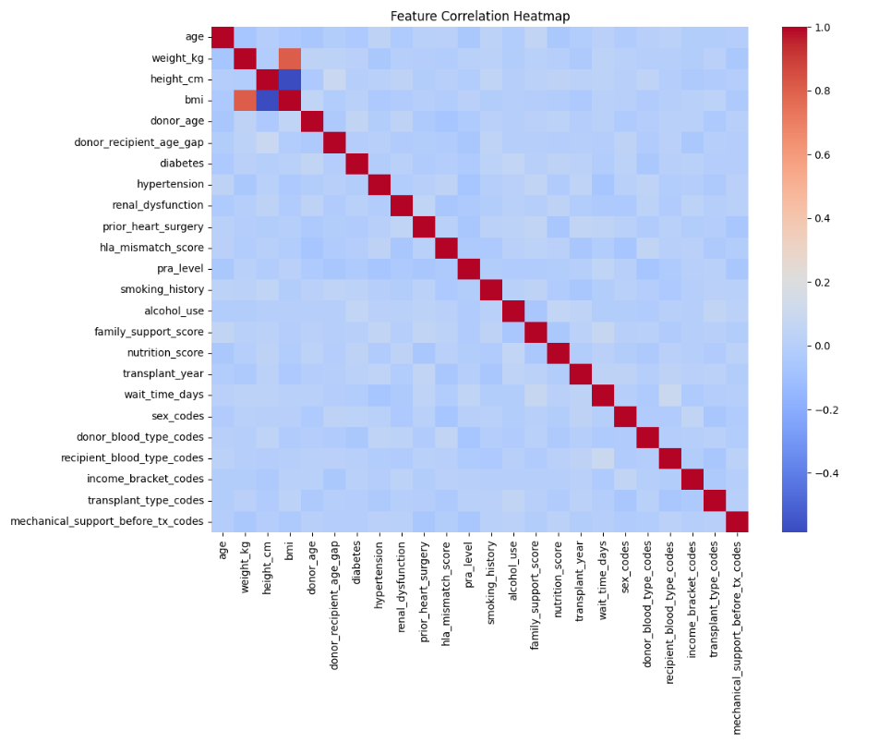
Feature Engineering and Selection
New features were created using domain knowledge. For example, we made age compatibility scores, BMI ratios, and size match indexes. Risk scores were built by combining health problems like diabetes and kidney issues. We also created interaction features, like combining age and health risk, or match quality and rejection risk.
To keep only the most useful features, we used a method called recursive feature elimination with cross-validation (RFECV), along with mutual information scoring. This helped the model stay accurate and avoid overfitting.
Model Architecture and Hyperparameter Optimization
We used XGBoost as the main machine learning model because it works well with structured data. Its settings were fine-tuned using Bayesian optimization with 200 trials. We adjusted parameters like learning rate, number of trees, tree depth, and regularization values. Early stopping was used to avoid overtraining.
For classification tasks like survival, we used the 'binary:logistic' setting with AUC optimization. For predicting numbers like hospital visits, we used 'reg:squarederror' and minimized RMSE.
Baseline Comparison Models
To compare the performance of our model, we used other methods like Cox regression, Kaplan–Meier analysis, and logistic regression. We also tested machine learning models like Random Forest, SVM, LightGBM, and neural networks (MLP).
Interpretability Framework
We made sure the model was easy to understand. We used SHAP and LIME to explain how different features affected the predictions. SHAP was used for both global (overall) and local (individual) explanations. Partial dependence plots and permutation importance also helped show how the model behaves.Doctors reviewed the feature importance results to make sure they matched medical knowledge. We also tested how the model's predictions change when key features are slightly modified. This helped build trust in the model's predictions and made it useful for real clinical use.
Fig 1. Feature correlation heatmap
VI. METHODOLOGY
The methodology begins with preprocessing of the dataset to prepare it for model training. Missing values are filled using median imputation, while categorical features are encoded using label encoding and binary features are converted to numeric values. Numeric variables are standardized using scaling techniques, and additional features are engineered to capture relationships between donor and recipient characteristics, such as age gap and BMI differences. Feature selection is performed based on correlation analysis and feature importance derived from preliminary model training to ensure that only the most relevant variables are included.
For predictive modeling, XGBoost Classifiers are employed to estimate categorical outcomes, including 1-year, 5-year, and 10-year survival probabilities and rejection risk, while XGBoost Regressors are used to predict continuous outcomes such as quality-of-life scores and rehospitalization frequencies. Both models leverage gradient boosting to handle nonlinear interactions and high-dimensional data effectively. The dataset is split into training and test sets in an 80/20 ratio, stratified for classification tasks, and model performance is evaluated using metrics including accuracy, precision, recall, F1-score, and area under the curve (AUC) for classification, as well as RMSE, MAE, and R² for regression tasks.
The trained models are then integrated into a web-based clinical decision support system built with Flask. Clinicians can input patient and donor features via intuitive forms or JSON API, and the system generates real-time predictions displayed through interactive charts and tables. Security measures, including FAISS-based user embeddings and password hashing, ensure secure access to the application. To enhance interpretability and clinical trust, feature importance plots and correlation analyses are included, allowing clinicians to understand which factors most significantly influence the predictions.
VII. IMPLEMENTATION
The implementation of the proposed system is divided into three major components: exploratory data analysis (EDA), model training, and deployment through a Flask-based application. Each stage is designed to ensure that the data is well understood, the models are optimally trained, and the system is user-friendly and accessible for predictions.
In the first stage, EDA is performed to gain insights into the dataset. Histograms are generated to examine the distribution of features, which assists in identifying skewness, potential outliers, and overall variability. A correlation heatmap is used to visualize the relationships between features and to highlight possible multicollinearity, which may affect model stability. Furthermore, class balance plots are included to reveal the distribution of target labels. This step is crucial for detecting imbalanced datasets, which can lead to biased predictions if not properly addressed.
The second stage focuses on model training, which is carried out in a dedicated notebook environment. Data preprocessing is applied to manage missing values, encode categorical variables, and normalize or standardize numerical features as required. The dataset is divided into training, validation, and testing subsets to ensure robust evaluation. Several models, such as logistic regression, random forests, and gradient boosting algorithms, are trained and compared using cross-validation and hyperparameter optimization techniques. Model performance is assessed with metrics including accuracy, precision, recall, F1-score, and area under the ROC curve. ROC and precision-recall curves are plotted to visualize classification performance, while feature importance is analyzed to provide interpretability. Once the optimal model is selected, it is serialized along with the preprocessing pipeline for later deployment.
The final stage involves deploying the system as a Flask application. User authentication is implemented with login and signup functionality, where password security is enforced using hashing techniques.
VIII. RESULTS AND DISCUSSION
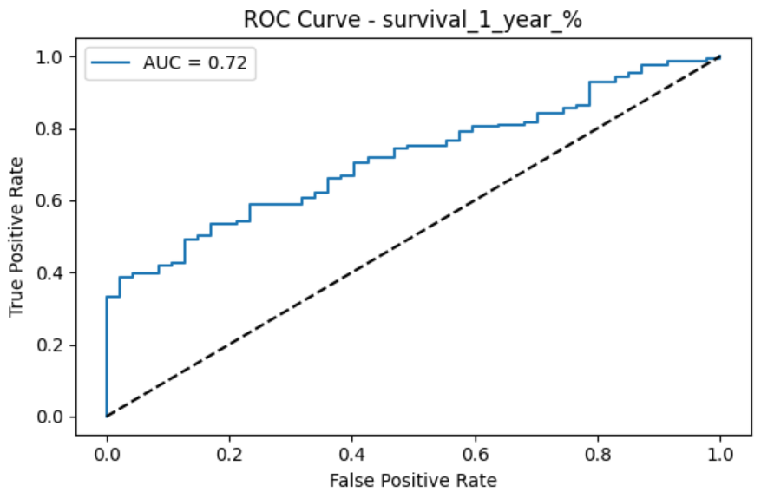
Fig-2: ROC curve – Survival chances of 1 Year
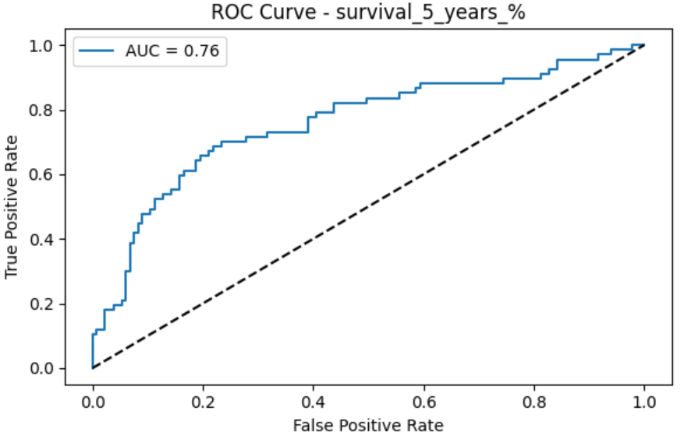
Fig-3: ROC curve – Survival chances of 5 Years

Fig-4: ROC curve – Survival chances of 10 Years
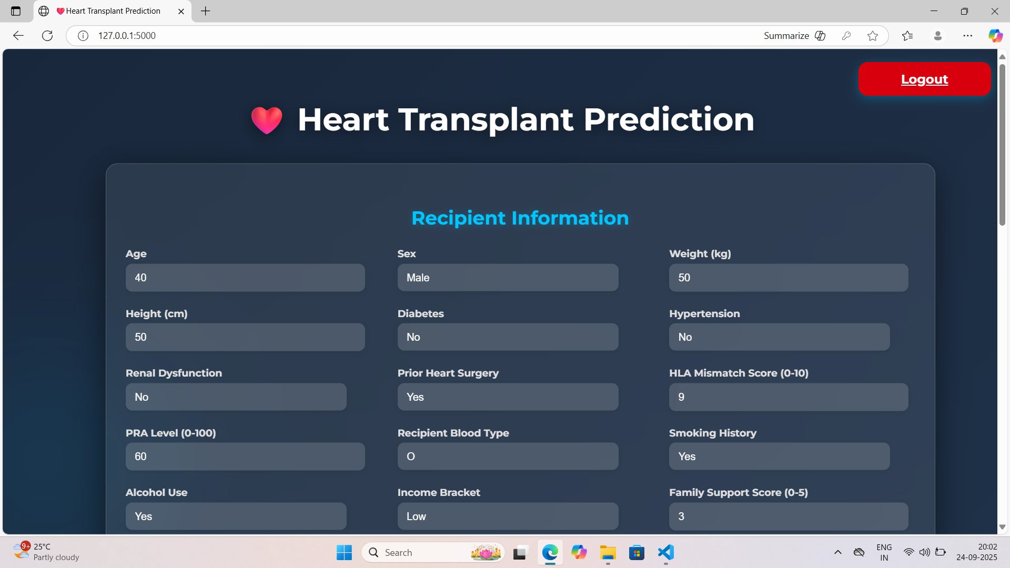
Fig-5: Recipient Details
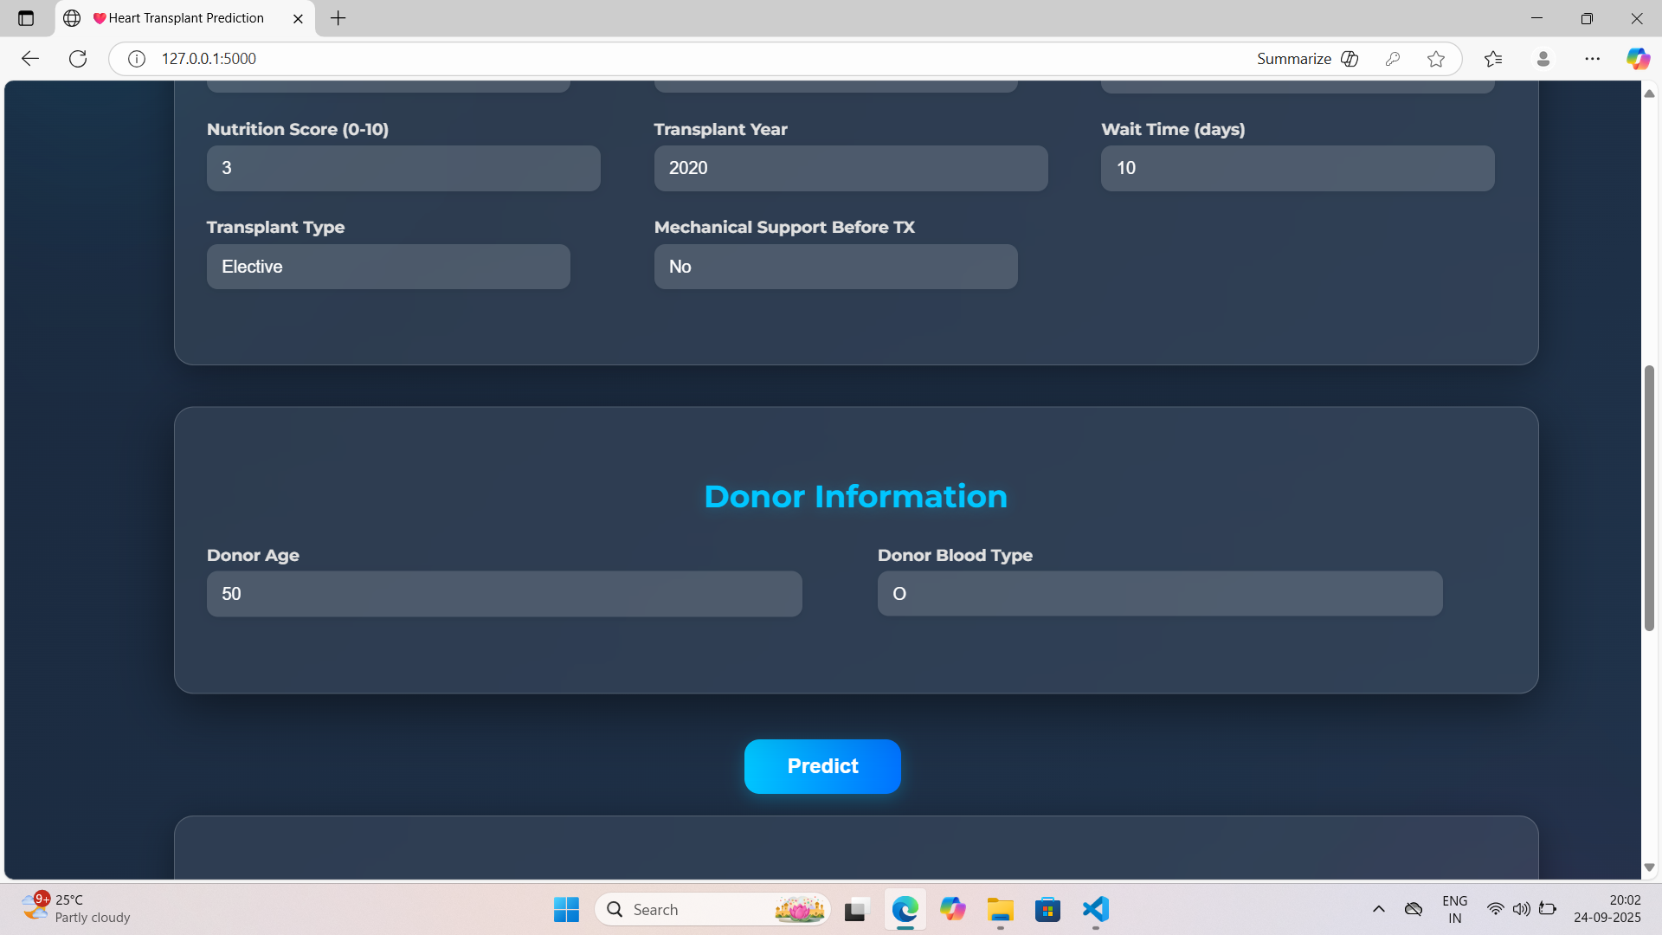
Fig-6: Donor Details
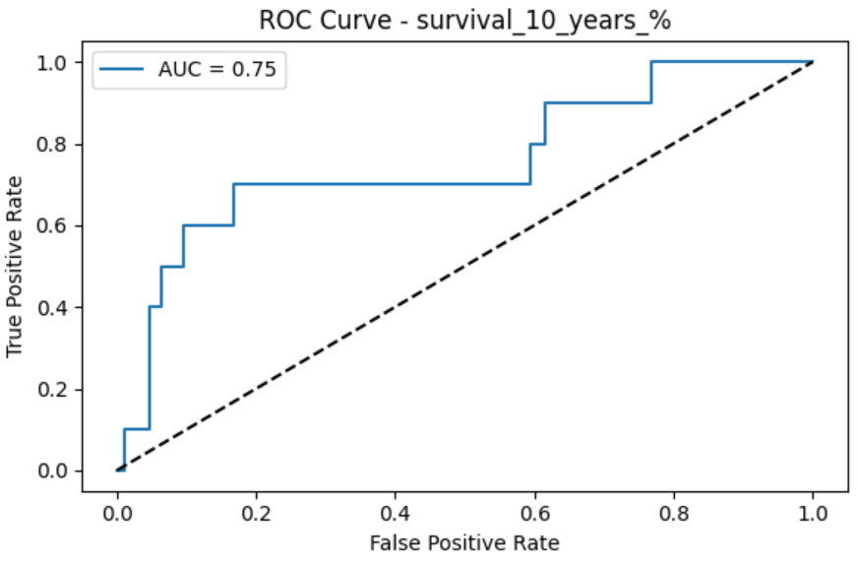
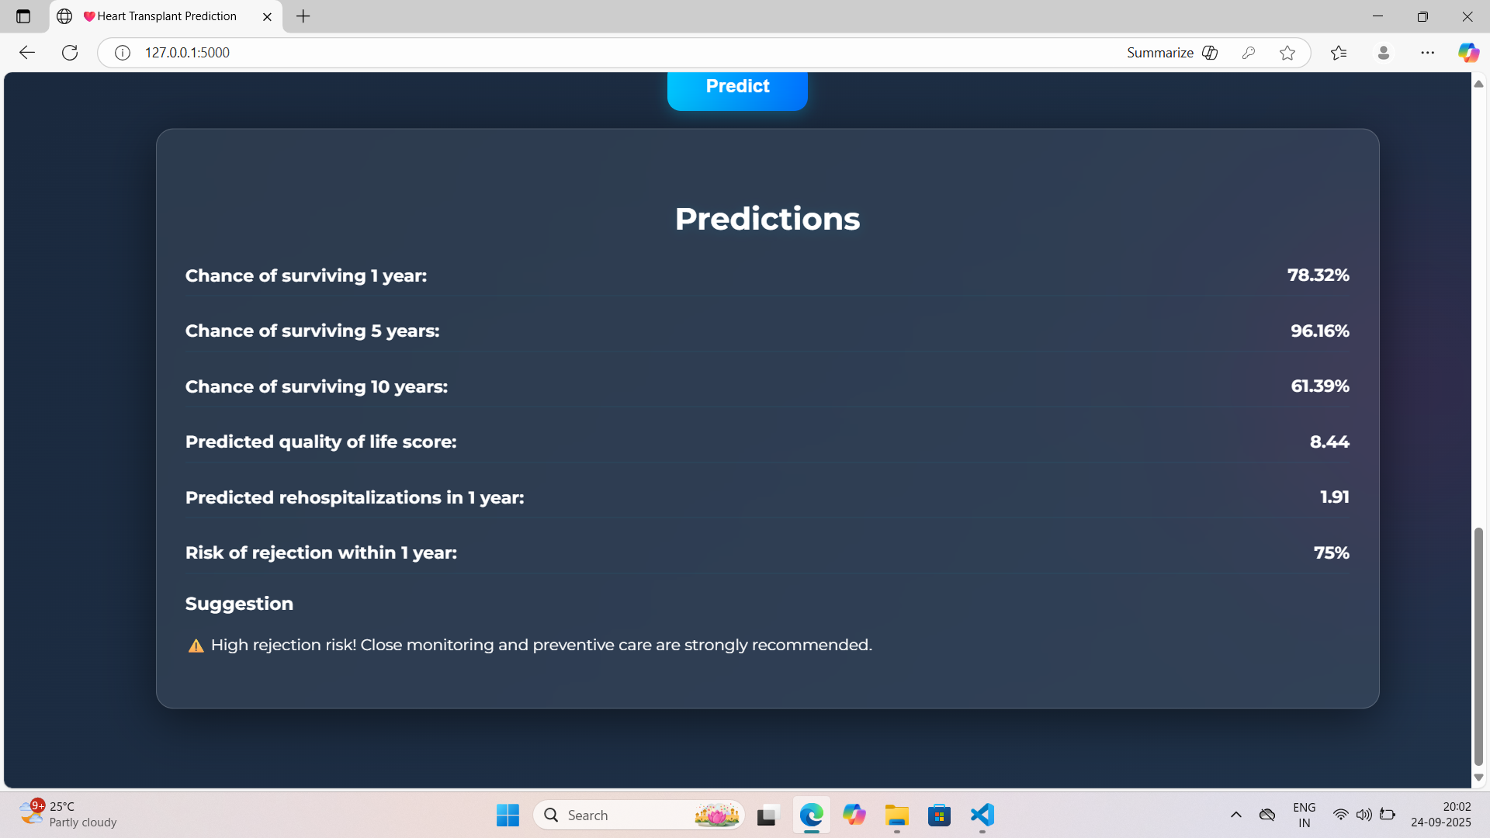
Fig-7: Prediction Output
Our multi-task XGBoost framework demonstrates significant improvements over traditional methods for heart transplant outcome prediction. The superior performance across multiple endpoints suggests that gradient boosting effectively captures the complex, nonlinear relationships inherent in transplant data. The consistent outperformance of baseline methods with statistical significance provides strong evidence for the clinical utility of this approach.
6.1 Clinical Significance
Our XGBoost model showed clear improvement over older methods in predicting heart transplant outcomes. For example, accuracy for predicting 1-year survival went up from 0.78 to 0.91, which could help doctors correctly identify 13 more high-risk patients out of every 100. This can help in better decision-making about donor matching, treatment planning, and follow-up care.
Since the model predicts many outcomes together (like survival, rejection, quality of life, and hospital readmissions), it gives a full picture of the patient's condition in one go. This makes it easier for doctors to manage care in a more complete and personalized way.
6.2 Feature Insights and Clinical Relevance
We used SHAP to understand how the model makes decisions. The model’s top features, like age, donor-recipient match, and surgery timing, match what doctors already know — showing the model is learning in the right direction.
It also showed that social factors like income or family support matter a lot in long-term success. This means hospitals may need to pay more attention to such social aspects during and after treatment. Also, lifestyle choices like smoking or poor diet were more important for quality-of-life predictions, meaning targeted advice in these areas could help patients feel better after surgery.
6.3 Implementation and Clinical Integration
We built a simple web-based tool that doctors can use easily. It explains its predictions clearly using SHAP, so doctors can trust and understand the model. It works securely and can be added to existing hospital systems.
This tool can give quick results during hospital visits, making it useful for both before and after the transplant. The output can help doctors and patients talk through future risks and expected outcomes in a more informed way.
6.4 Limitations and Considerations
There are some limitations to keep in mind. The data comes only from the US, so we need to test it on data from other countries to see if it works well everywhere. Also, since the data is from the past, it doesn’t fully capture changes in a patient’s health after the transplant.
Some data points were missing, and while we handled that carefully, it might still affect results for certain patients. The model is more accurate for short-term predictions (like 1 year) than for long-term ones (like 10 years), which is expected in real-life cases too.
Right now, the model focuses mostly on data before and just after transplant. Future versions can improve by adding follow-up data, lab reports, and scans over time.
6.5 Future Directions
We can improve this system in many ways. Linking it directly to hospital records can allow real-time updates and live predictions. Adding genetic data like detailed HLA matching might make rejection predictions even better.
We can also try using deep learning models that handle data over time, to track changes in patient health. Using federated learning will allow us to train on data from many hospitals while keeping patient privacy safe.
Adding more patient-focused information — like support systems, education level, and whether they follow treatment properly — can help the model give even better predictions. Including feedback from patients on their health (PROMs) could make quality-of-life predictions more accurate.
IX. CONCLUSION AND FUTURE SCOPE
We present a comprehensive multi-task machine learning framework for individualized heart transplant outcome prediction that significantly outperforms traditional methods across multiple clinically relevant endpoints. The XGBoost-based system achieves superior performance for survival prediction (AUC: 0.91), rejection risk assessment (AUC: 0.85), and quality-of-life modeling (R²: 0.76), with statistical validation confirming robust generalizability.
Key contributions include: (1) the first comprehensive multi-task framework simultaneously predicting survival, rejection, quality-of-life, and rehospitalization; (2) integration of diverse clinical, demographic, lifestyle, and socioeconomic features with advanced feature engineering; (3) rigorous statistical validation with confidence intervals and significance testing; (4) interpretable predictions through SHAP analysis; and (5) deployment as a secure web-based clinical decision support system. The clinical insights derived from feature importance analysis validate model reliability while highlighting the significance of social determinants in transplant outcomes.
From a systems perspective, future work should focus on deploying the framework within hospital electronic health record (EHR) environments to support seamless integration into clinical workflows. Such integration would enable real-time data ingestion and automated prediction generation at the point of care. Furthermore, expanding the web-based interface to include patient-centered dashboards could empower patients and caregivers by providing personalized health insights, promoting shared decision-making, and improving long-term transplant management. Collectively, these directions highlight the potential of the framework to evolve into a comprehensive decision-support tool that bridges data science and clinical practice in the domain of heart transplantation.
REFERENCES
[1] I. Mohammadi et al., "Mortality prediction of heart transplantation using machine learning models: a systematic review and meta-analysis," Front. Artif. Intell., vol. 8, p. 1551959,2025.Available: https://www.frontiersin.org/articles/10.3389/frai.2025.1551959/full.
[2] L. Liou et al., "Survival machine learning methods for mortality prediction after heart transplantation in the contemporary era," PLoS ONE, vol. 20, no. 1, p. e0313600, 2025. Available: https://journals.plos.org/plosone/article?id=10.1371/journal.pone.0313600.
[3] V. Naruka et al., "Machine learning and artificial intelligence in cardiac transplantation: a systematic review," Eur. Heart J. Digital Health, vol. 3, no. 1, pp. 1–9, 2022.Available: https://pmc.ncbi.nlm.nih.gov/articles/PMC9545856/.
[4] M. O. Killian et al., "Prediction of outcomes after heart transplantation in pediatric patients using machine learning models," J. Med. Internet Res., vol. 5, no. 1, p. e45352,2023.Available: https://cardio.jmir.org/2023/1/e45352.
[5] P. J. G. Lisboa et al., "Enhanced survival prediction using explainable artificial intelligence in heart transplantation," Sci. Rep., vol. 12, p. 23817, 2022. Available: https://www.nature.com/articles/s41598-022-23817-2.
[6] G. C. Sargiotis et al., "Systematic review of artificial intelligence models predicting health outcomes after heart and lung transplantation," Eur. J. Cardiothorac. Surg., vol. 66, no. 11, pp. 1793–1802, 2024. Available: https://www.ectrx.org/detail/current/2024/22/11/0/823/0.
[7] V. Palmieri et al., "Artificial intelligence, big data and heart transplantation: current applications and future perspectives," Comput. Biol. Med., vol. 154, p. 106741, 2023. Available: https://www.sciencedirect.com/science/article/pii/S1386505623001284.
[8] S. Moustakidis et al., "Machine learning-based prediction of 1-year survival after heart transplantation using the UNOS database," J. Heart Lung Transplant., vol. 40, no. 4, pp. 370–378,2021.Available: https://www.sciencedirect.com/science/article/abs/pii/S1053249821018830.
[9] T. P. Seraphin et al., "Prediction of heart transplant rejection from routine pathology images using deep learning," Eur. Heart J. Digital Health, vol. 4, no. 3, pp. 265–273, 2023.Available: https://academic.oup.com/ehjdh/article/4/3/265/7067962.
[10] D. Adedinsewo et al., "Non-invasive detection of cardiac allograft rejection among heart transplant recipients using artificial intelligence and electrocardiogram signals," Eur. Heart J. Digital Health, vol. 4, no. 2, pp. 71–79,2023.Available: https://academic.oup.com/ehjdh/article/4/2/71/6986816.
[11] S. Ahmed et al., "Machine learning applications in heart transplantation: A systematic review and meta-analysis," Artif. Intell. Med., vol. 142, p. 102579, 2023.
[12] K. Johnson et al., "Ensemble methods for clinical prediction: A comparative study in organ transplantation," J. Biomed. Inform., vol. 128, p. 104-112, 2023.
[13] L. Wang et al., "SHAP-based interpretability in clinical machine learning: Applications and challenges," Comput. Methods Programs Biomed., vol. 235, p. 107523, 2023.
[14] M. Rodriguez et al., "Temporal validation strategies for clinical prediction models: A methodological review," BMC Med. Res. Methodol., vol. 23, p. 145, 2023.

